1. Compare and contrast different Data storage mechanisms.

**Hard Drives**. Solid-State Drives (SSD) CD/DVD Drives. Flash Drives.

1. a) What is known as the ANSI/SPARC model? Give another name for the ANSI/SPARC model.

The ANSI-SPARC Architecture (American National Standards Institute, Standards Planning And Requirements Committee), is **an abstract design standard for a database management system (DBMS)**, first proposed in 1975. The ANSI-SPARC model however never became all formal standard.

b) Draw the Three Schema Architecture. Name the three schemas.

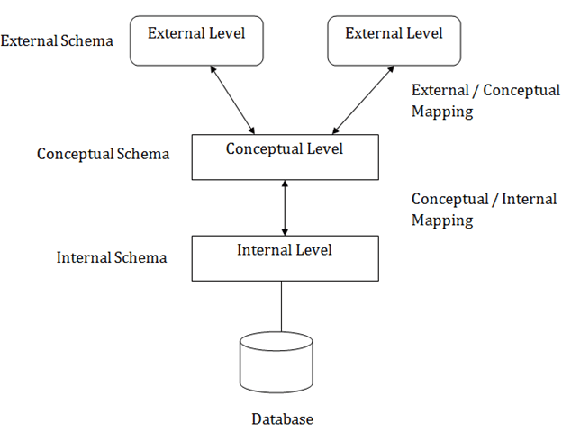

c) Briefly explain the 3 schemas.

The three-schema architecture divides the database into three-level used to create a separation between the physical database and the user application. In simple terms, this architecture hides the details of physical storage from the user.

The database administrator (DBA) responsible is to change the structure of database storage without affecting the user’s view. It deals with the data, the relationship between them and the different access methods implemented on the database. The logical design of database is called a schema

This architecture contains three layers of database management system, which are as follows −

* External level
* Conceptual level
* Internal level

**External/ View level**

This is the highest level of database abstraction. It includes a number of external schemas or user views. This level provides different views of the same database for a specific user or a group of users. An external view provides a powerful and flexible security mechanism by hiding the parts of the database from a particular user.

**Conceptual or Logical level**

This level describes the structure of the whole database. It acts as a middle layer between the physical storage and user view. It explains what data to be stored in the database, what the data types are, and what relationship exists among those data. There is only one conceptual schema per database.

This level describes the structure of the whole database. It acts as a middle layer between the physical storage and user view. It explains what data to be stored in the database, what the data types are, and what relationship exists among those data. There is only one conceptual schema per database.

**Internal or Physical level**

This is the lowest level of database abstraction. It describes how the data is stored in the database and provides the methods to access data from the database. It allows viewing the physical representation of the database on the computer system.

The interface between the conceptual and internal schema identifies how an element in the conceptual schema is stored and how it may be accessed. It is one which is closest to physical storage. The internal schema not only defines different stored record types, but also specifies what indices exist, how stored fields are represented.

d) What is the advantage of having the three schema architecture?

**Same data can be accessed by different users with different customized views**. The user is not concerned about the physical data storage details. Physical storage structure can be changed without requiring changes in internal structure of the database as well as users view.

e) What do you mean by logical data independence and physical data independence?

Physical data independence helps you to separate conceptual levels from the internal/physical levels. **Logical Data Independence is the ability to change the conceptual scheme without changing**. When compared to Physical Data independence, it is challenging to achieve logical data independence.

3. ‘Sri Lankan Airline is the national carrier’.

a) What are possible data required by an airline system?

All the data within the system is solely for your airline so set up and configuration is made during the training and consultation period to ensure the system behaves and functions as required. **Other Airlines Codes, GDS Codes, Countries, Cities, Currencies, Times Zones, Aircraft Types, Airport taxes**.

b) Is it necessary for them to use a DBMS?

Yes. Database management systems **help users share data quickly, effectively, and securely across an organization**. By providing quick solutions to database queries, a data management system enables faster access to more accurate data.

4. Think of a DB of a bank.

1. What type of data would they store in their database?

Banking transaction systems store data in databases containing **information about customers, accounts, and transactions against those accounts**.

1. In the three schema architecture where would you put details about above data?

Three-schema architecture is an idea in relational database design that **breaks a database down into three different categories according to its use and structure, and to the roles played by system administrators, designers and end users**

1. In the three schema architecture which schema describes details about the type of file organization used to store the above data?

The **external or view level** includes a number of external schemas or user views. Each external schema describes the part of the database that a particular user group is interested in and hides the rest of the database from that user group.

1. What is the advantage of using a DBMS for a bank?

**Lower Costs**. A distributed database management system allows each bank branch to have its own copy of the latest customer data. The bank's copy of the customer's account data allows the bank to record and process each transaction locally, rather than sending it forward to a central server